Chapter 9, Solution 49.

Find v_{s}(t) in the circuit of Fig. 9.56 if the current i_{x} through the 1-Ω resistor is
500 sin(200t) mA.

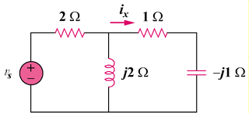

Figure 9.56
For Prob. 9.49.

Solution

-j

I

I_{x}

j2

1

, where

1.4142 sin(200t – 45) V

